Physical Science - Chapter 2 and 3 Study Guide
- Explain the difference between distance and displacement.
- A sprinter runs 300 m west and then turns around and goes 100 m east. Her displacement is:
- The speed of a motorcycle at a particular moment is its ______________ speed.

- In 15 minutes, a bicyclist traveled 10 kilometers. What was the bicyclist's average speed?

- A fly is sitting still on the counter top. It takes off and accelerates at a rate of 4 m/s² for 3 seconds. How fast was the fly going after the three seconds?
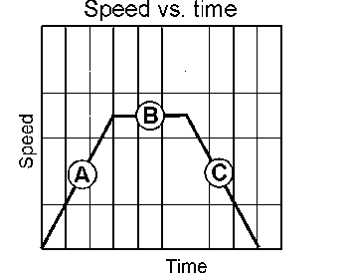
- A car is stopped at a red light. When the light turns green it accelerates to 35 mph in 0.02 hours. What is it’s acceleration?

- Explain what is happening at points A, B and C on the
speed vs time graph

- Explain how something can have a negative acceleration.

- Explain how something can be moving and have zero acceleration. Provide an example.

- Explain Newton’s 3 Laws of Motion:
1st:
2nd:
3rd:
- The resultant force on the above box is:

- Define:
Air Resistance:
Friction:
Centripetal force:
- What is the force being applied to an object that has a mass of 20 kg and is accelerating at 3 m/s²

- What is the mass of an object that is accelerating at 15 m/s² when a force of 3000 N is exerted?

