Mini Lab: Calculating GPP and NPP Name ____________________________________
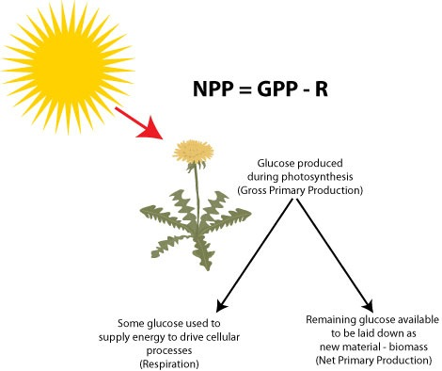
Period _______________

Look at the diagram above. Write a caption/description for this diagram. Make it detailed-similar to what you see in your textbook figures.

Open this Video and answer the questions while watching the video: https://youtu.be/voSQZcqgYNY
- Where and what is the sample of water used in this lab?

- What is the dissolved oxygen (DO) reading of the water sample? ____________________ mg/L
- How many bottles are filled? ______________
- Why was the lid of the bottle put on under the water?

- What plant is put in each bottle? ____________________
- Describe the treatment to each bottle. (What was done differently to each bottle?) Why?

Pause the video and use what you’ve learned about experimental design to answer these questions:
- List 4 constants (the things that are the same for each bottle) in this lab:

- What is the independent variable? ______________________________________
- What is the dependent variable? (What will we measure?) ________________________________
Play the video to get the results and answer these questions:
10. What is the DO level of the bottle that was in the light? _______________ mg/L
11. What is the DO level of the bottle that was in the dark? _______________ mg/L
Fill in this chart:
Initial Dissolved Oxygen (ppm) (both bottles) | Final Dissolved Oxygen in Dark Bottle (no photosynthesis, only respiration) | Final Dissolved Oxygen in Light Bottle (both respiration and photosynthesis)
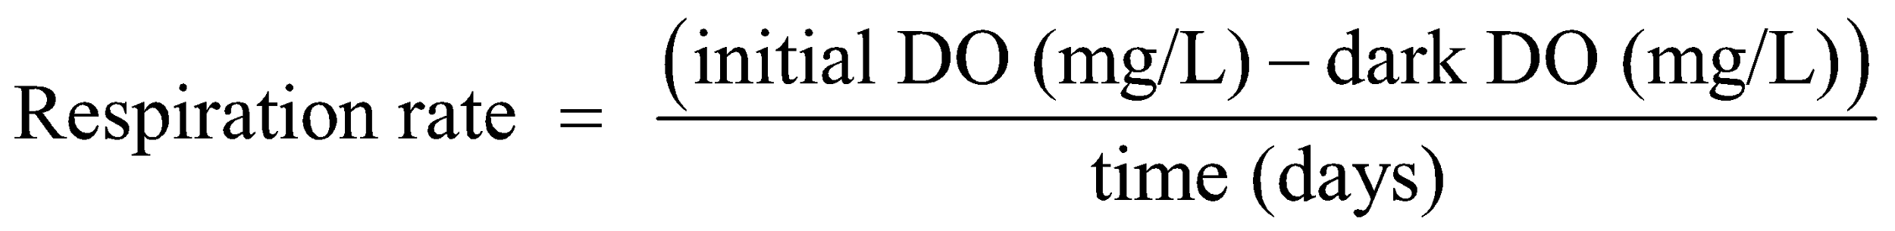
12. Calculating Respiration Rate: Only respiration (and not photosynthesis) can occur in a dark bottle. Respiration rate is the decrease in DO over time. To determine this for your sample, subtract the dark DO from the initial DO, then divide it by the time (usually in days). This will give an answer in mg O₂/L/day. Use the formula below to assist you. In a water solution, ppm = mg/L

R =

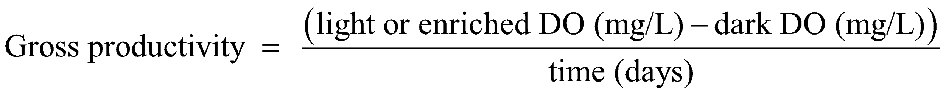
13. Calculating Gross Primary Productivity: Gross Primary Productivity (GPP) is the total amount of carbon that was fixed by organisms over a period of time. To determine this for your sample, subtract the dark bottle DO from the light DO values, then divide it by the time (usually in days). This will give an answer in mg O₂/L/day. Use the formula below to assist you.

GPP =

14. Calculating Net Primary Productivity: Net Primary Productivity (NPP) is the total amount of carbon that was fixed by organisms into living tissue minus that used for respiration over a period of time To determine this for your sample, subtract the respiration rate in mg O₂/L/day from GPP in mg O₂/L/day. This will give an answer in mg O₂/L/day. Use the formula NPP = GPP - R

NPP =

15. You can also use the formula below to calculate the net primary productivity since the difference between the light bottle DO and the initial DO is essentially the same algebraic expression as GPP minus respiration rate.
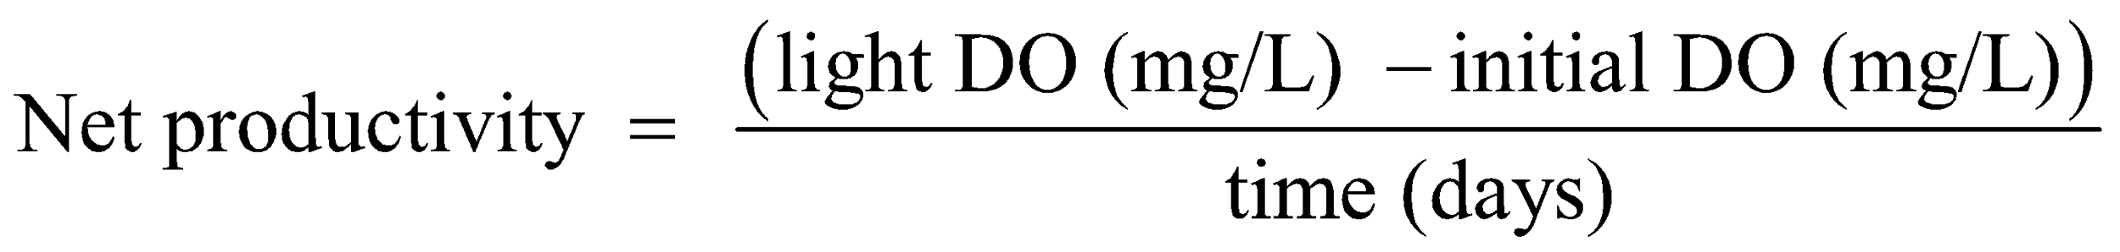

NPP =

In this lab, we measured the amount of oxygen that was laid down into biomass. In other words, the amount of Oxygen that was turned into tissues on the bodies of the plant.

Typically, however, we would mass the producers and calculate the amount of calories available for consumers as energy if they ate the producers.

More Practice:
16. The gross primary productivity of an ecosystem is 3.5 kgC/m²/year, and the energy needed by the producers for their own respiration is 3.0 kgC/m²/year. What is the net primary productivity of such an ecosystem?

17. The net annual primary productivity of a particular wetland ecosystem is found to be 2,000 kcal/m². If respiration by the aquatic producers is 18,000 kcal/m² per year, what is the gross annual primary productivity for this ecosystem, in kcal/m² per year?

18. Energy flow in Lake Fremont (kcal/m²/year)
Trophic Level _ Energy Consumed _ Waste Energy _ _ GPP _ NPP _
Producer - 1,500,000 10,000 8,000
Primary Consumer 2,000 1,600 200 180
Secondary Consumer 160 100 40 10

In the community described in the table above, which of the following represents the respiratory energy (kcal/m²/year) used by autotrophic organisms?
a) 10 b) 200 c) 1,600 d) 2,000 e) 10,000

19. Which 3 ecosystems have the highest productivity and which 3 have the lowest productivity?

20. How does productivity increase in terrestrial ecosystems? In aquatic ecosystems?

21. Is our biome/ecosystem highly productive? Explain why or why not.

